AI-ASSISTANT CODING
ASSIGNMENT – 4.3
Task 1: Zero-Shot Prompting – Leap Year Check
Scenario
Zero-shot prompting involves giving instructions without providing examples.
Task Description
Use zero-shot prompting to instruct an AI tool to generate a Python function that:
- Accepts a year as input
- Checks whether the given year is a leap year
- Returns an appropriate result
Note: No input-output examples should be provided in the prompt.
Expected Output
- AI-generated leap year checking function
- Correct logical conditions
- Sample input and output
- Screenshot of AI-generated response (if required)

Promt : checking leap year or not

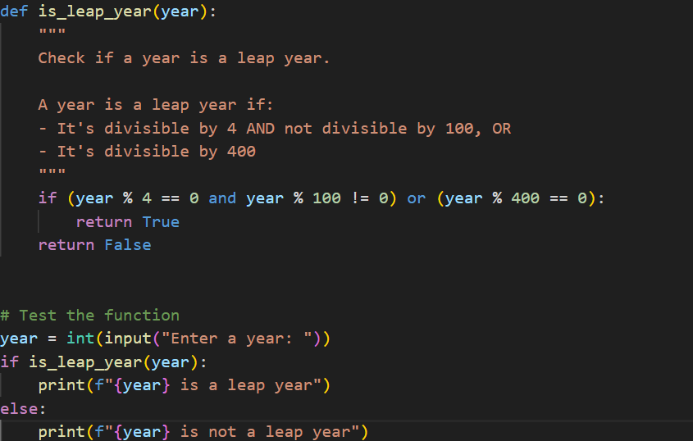

Output:
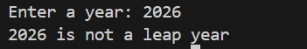
Task 2: One-Shot Prompting – Centimeters to Inches Conversion
Scenario
One-shot prompting guides AI using a single example.
Task Description
Use one-shot prompting by providing one input-output example to generate a Python function that:
- Converts centimeters to inches
- Uses the correct mathematical formula
Example provided in prompt:
Input: 10 cm → Output: 3.94 inches
Expected Output
- Python function with correct conversion logic
- Accurate calculation
- Sample test cases and outputs

Prompt:input=10cm
output=3.94 inches
conversion from cm to inches using formula
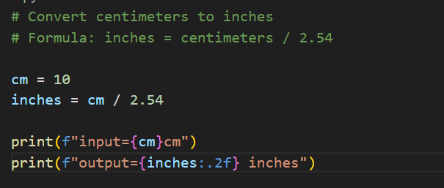
Output:
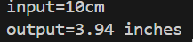
Testcases:
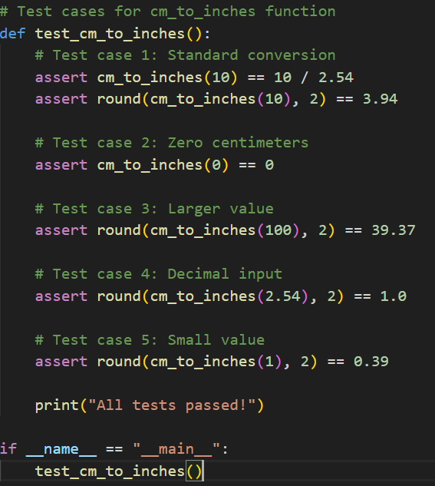
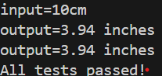
Task 3: Few-Shot Prompting – Name Formatting
Scenario
Few-shot prompting improves accuracy by providing multiple examples.
Task Description
Use few-shot prompting with 2–3 examples to generate a Python function that:
- Accepts a full name as input
- Formats it as “Last, First”
Example formats:
- "John Smith" → "Smith, John"
- "Anita Rao" → "Rao, Anita"
Expected Output
- Well-structured Python function
- Output strictly following example patterns
- Correct handling of names
- Sample inputs and outputs

Prompt:
Input ="John Smith" → output = "Smith, John"
Input ="Anita Rao" → output = "Rao, Anita"
Generate a code to print the above examples
usage of python function,handle names correctly

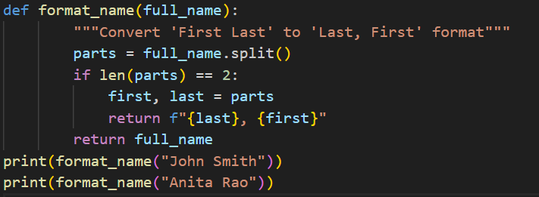
Output:
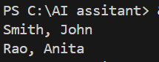

Task 4: Comparative Analysis – Zero-Shot vs Few-Shot
Scenario
Different prompt strategies may produce different code quality.
Task Description
- Use zero-shot prompting to generate a function that counts vowels in a string
- Use few-shot prompting for the same problem
- Compare both outputs based on:
  - Accuracy
  - Readability
  - Logical clarity
Expected Output
- Two vowel-counting functions
- Comparison table or short reflection paragraph
- Conclusion on prompt effectiveness

Prompt:
ZERO SHOT : generate a code to count number of vowels

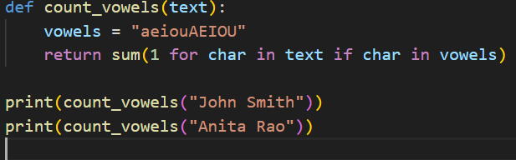
OUTPUT:
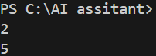

ONE SHOT :
Input = "John Smith" → ouput = 2
Input = "Anita Rao" → output = 3
Generate a code that counts how many vowels in the above strings

Output:


Task 5: Few-Shot Prompting – File Handling
Scenario
File processing requires clear logical understanding.
Task Description
Use few-shot prompting to generate a Python function that:
- Reads a .txt file
- Counts the number of lines in the file
- Returns the line count
Expected Output
- Working Python file-processing function
- Correct line count
- Sample .txt input and output
- AI-assisted logic explanation

Prompt:
Input:
File has 3 lines
Output:
Line count = 3

Example 2

Input:
File has 5 lines
Output:
Line count = 5
c:\Users\thimi\OneDrive\Documents\AI PROJECT PARENT(1).docx
• code to print the Count of the number of lines in the file

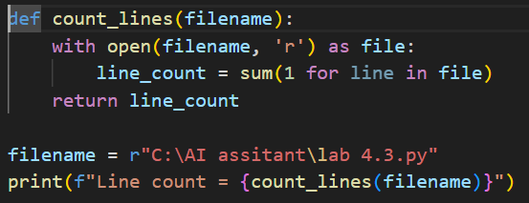

Output:
